

**YEAR: 7**

**SUBJECT: SCIENCE**

**Quiz: Classification**

**TIME: 30 mins**

**QUESTIONS: Part A: Multiple Choice Questions (10 marks)**

**Part B: Short Answer Questions (15 marks)**

**TOTAL MARKS: 25 marks**

**Name _____________________________________________________________________________**

**Multi choice Section (10 questions) Circle the correct answer 10 Marks**

1. Which of the following is not a feature of **all** living things?

a. They reproduce.

b. They grow.

c. They are composed of cells.

d. They photosynthesise.

2. All living things respond to stimuli. Which of the following is an example of a stimulus?

a. Heat

b. Pressure

c. Sunlight

d. All of the above

3. Scientists classify organisms because:

a. it makes it easier to identify organisms.

b. there are only a few organisms that differ from each other.

c. most discoveries in biology have already been made.

d. all organisms have characteristics in common.

4. The reason for using structural characteristics (rather than colour or size) for classification is:

a. structural features are easy to observe.

b. individuals of the same type can differ in colour.

c. organisms change size as they grow.

d. all of the above.

5. What is the main difference between plants and animals?

a. Plants make their own food; animals need a source of food.

b. Animals reproduce, plants don’t.

c. Animals need water, plants don’t need water.

d. Plants are more complicated than animals.

6. Organisms can be grouped into five major kingdoms. These are:

a. mammals, fish, birds, amphibians and reptiles.

b. animals, fungi, monera, plants and protists.

c. animals, fungi, insects, plants and algae.

d. animals, plants, insects, birds and reptiles.

7. Kingdoms themselves can be sub-divided. The sequence of classification following kingdoms is:

a. species, phylum, class, order, family, genus.

b. class, order, family, genus, species, phylum.

c. order, family, genus, phylum, class, species.

d. phylum, class, order, family, genus, species.

**The diagram shows four characters, and a key to identify them.**

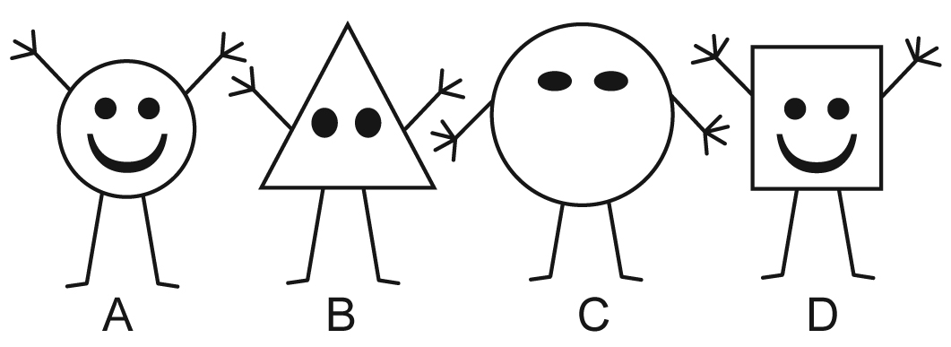

1 Round body Go to 3.

Not round body Go to 2.

2 Three fingers Gertie

Four fingers . Iris

3 Mouth Fred

No mouth Harry

8. Which one is Harry?

a. A

b. B

c. C

d. D

9. Which one is Iris?

a. A

b. B

c. C

d. D

10. A vertebrate is an animal which has:

a. a backbone .

b. a hard shell.

c. wings.

d. fins

**Part A: Multiple Choice Answers (1mark each)**

Put a cross (X) through the correct answer.

**1** a b c d

**2** a b c d

**3** a b c d

**4** a b c d

**5** a b c d

**6** a b c d

**7** a b c d

**8** a b c d

**9** a b c d

**10** a b c d

**End of Section A**

**Written Answer Section Answer in the spaces provided 15 marks**

1. A round dark coloured blob was discovered in a rock pool. **Explain** 3 factors or observations which would help decide if it was living or non-living.

(6 marks)

(i)

(ii)

(iii)

If you decided it was living, what would you need to know to decide whether it was a plant or an animal?

(1 marks)

2. Biologists use keys to identify unknown organisms. Use the following key to find the class (**A-F**) that the pictured organisms belong to.

(4 marks)

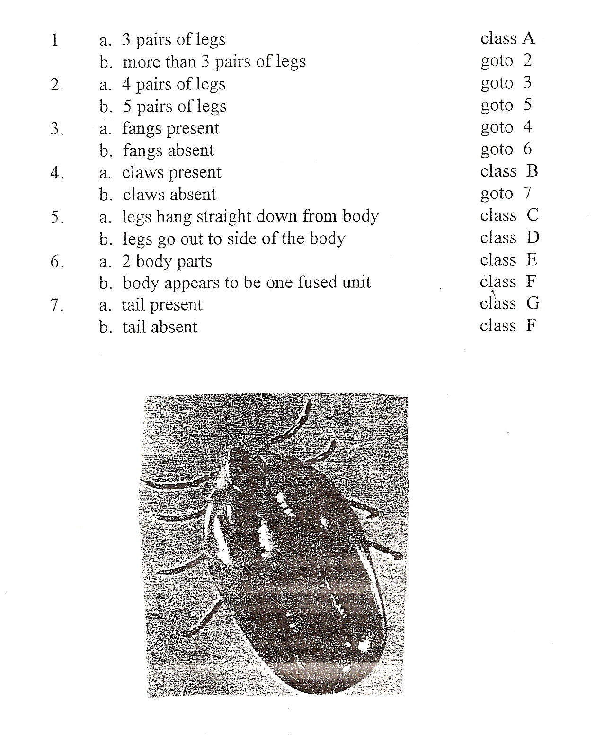

a.

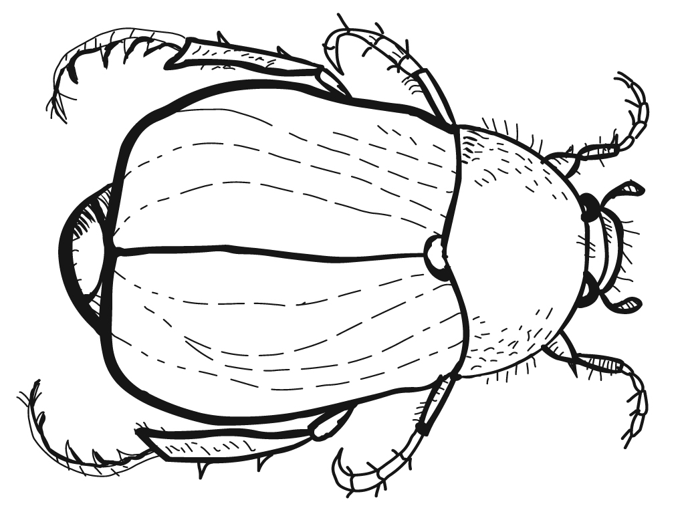

Class (A-F) _______

Write the numbered steps used to arrive at this answer ____________________________________

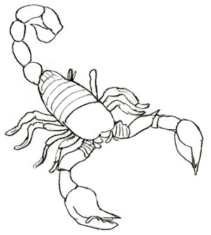

b.

Class (A-F) _______

Write the numbered steps used to arrive at this answer _____________________________________

3. Use the key below to classify the animals pictured here:

(4 marks)

**KEY ANIMAL**

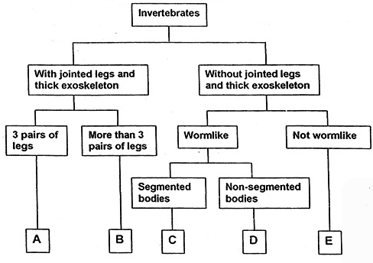

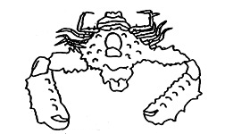

**I**

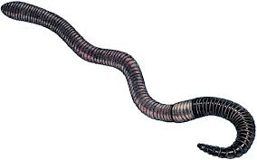

**II**

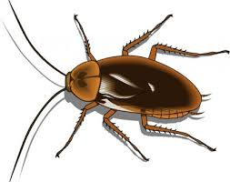

**III**

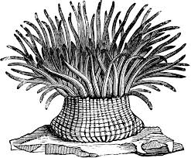

**IV**

|  |  |
| --- | --- |
| **ANIMAL** | **GROUP (A,B,C,D or E)** |
| **I** |  |
| **II** |  |
| **III** |  |
| **IV** |  |

**End of Test Total 25 marks**